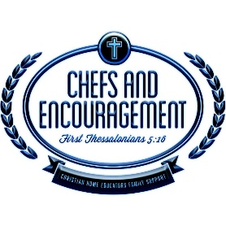

**Christian Home Educators Family Support (CHEFS) & Encouragement of Hunt County, Texas**

**Family Release of Liability**

**2018-2019 Membership Year**

In consideration of my family’s participation in any and all CHEFS & Encouragement activities, I, individually and on behalf of other parent or legal guardian of my children, attending and participating in CHEFS, agree to release, indemnify, forever discharge, and covenant not to sue CHEFS (including, but not limited to its officers, agents, board of directors, volunteers, instructors, helpers, other members/participants, affiliated clubs, sponsoring agencies, sponsors, and if applicable owners and lessors of premises used to conduct the event – including, but not limited to their boards of directors, elders, employees, paid staff and any other representatives). This signed document releases from any and all liability to me, my heirs, and next of kin for any and all claims, demands, losses or damages on account of injury including death, damage to property, loss of goods, loss of property, theft, to be caused or alleged to be caused in whole or in part by the negligence of CHEFS & Encouragement, and any causes of action which may result from participation for myself, my children, and any other individuals (including but not limited to, grandparents, friends, neighbors, foster children, extended family or minors temporarily in my care) I may bring to a CHEFS & Encouragement activity or event, including traveling to and from said activities and events.

I certify that my children & I are physically and medically able to participate in the activities and events in which we choose to participate and that there is no known medical condition which prevents them from participating in CHEFS activities and events. fully assume all risks of my family’s participation and involvement in ALL CHEFS & Encouragement planned, sponsored, managed or advertised events. This includes inspecting any facilities/equipment to ensure the safety of my family and guests.

Additionally, I assume full responsibility for the safety of my family while attending CHEFS events including ensuring my child and guests as outlined above will respect the property of the host location. If my child or guest is involved in any behavior that results in damage of any kind to the host location, I assume full responsibility including, but not limited to financial responsibility to ensure the items are replaced or repaired in a manner acceptable to CHEFS Board of Directors and the host facility.