Eta Sigma Alpha National Home School Honor Society

"The purpose of Eta Sigma Alpha National Home School Honor Society shall be to recognize and encourage scholarship among home school students. To achieve this purpose, Eta Sigma Alpha National Home School Honor Society shall provide opportunities for the development of leadership and service. Eta Sigma Alpha shall encourage the development of an intellectual climate that will stimulate the exchange of ideas and ideals, foster scholarship, and promote academic excellence. Eta Sigma Alpha shall also advocate homeschooling as a viable and successful educational methodology and act as a liaison for homeschooling to the general public, colleges/universities, and the media."

Students may apply as early as the summer of their 8th grade year. High school seniors’ applications will not be accepted after the October of their senior year.

Reward Academic Success

Membership in Eta Sigma Alpha National Home School Honor Society is an opportunity for home school scholars to be rewarded for their academic successes. We hope that you will choose to apply for this honor.

Membership Guidelines

Application Requirements

- Student must be a homeschooled student meeting the 51% rule (more than half of coursework is completed via home school.)
- The application may be submitted in the summer after the student’s 8th grade year through October of his/her 12th grade year, for membership during his/her 9th – 12th grade years. Senior Applications must be postmarked by 10/31 of the senior year. Junior year or earlier may apply at any time.
- Applicant must have a 3.5 grade point average on a 4-point scale and must supply a transcript with his/her application.
- Applicant must provide proof of test scores from one of the following tests: Iowa Achievement, (90% composite score), SAT ACT, CLT, PSAT, SAT 10, SAT 8/9. All test scores must be administered by someone other than the parent. Students must present a letter from the test administrator for all tests except SAT/PSAT/ACT. CLT at home test is not acceptable. See etasigmaalpha.com for current score requirements.
- Applicant must submit a short statement about why he/she would like to be a member of Eta Sigma Alpha (ESA) Beta Tau Chapter.
- Applicant’s parents must submit a letter of recommendation for their student/child.
- Applicant must submit letters from three additional references. These letters must be mailed to the address on the next page.
- Applicant must complete and submit an application form.

Commitment

- Actively participate in public service projects and submit 10 hours per year to ESA-Beta Tau.
- Act as a liaison for ESA to let others know about our organization.
- Uphold the ideas of leadership and service.

Maintain high scholastic and social standards.
- Pay yearly dues.

Beta Tau Chapter

Beta Tau Chapter
Eta Sigma Alpha National Home School Honor Society
Sponsored by the National Organization of ESA

Membership Application

Name
Address
City, St Zip

Phone Date of Birth
E-mail Address _______________ Name of Home School _________________________________________________

Current Grade Level ______________Date of Graduation: ______________
Current GPA (3.5 grade point average on a four-point scale required): _________

Please include the following documentation with your application:

- A copy of your transcript.
- Test score from one of these two groups of tests:
  - the IOWA (90% composite score). Also, include a letter from the test administrator confirming that it was administered by someone other than your parent(s).
  - SAT, PSAT, SAT 10, SAT 8/9; or ACT (see etasigmalpha.com for current score requirements)
- A short statement about why you would like to be a member of Eta Sigma Alpha.
- A letter of recommendation from your parent(s).
- Three letters of recommendation from someone other than your parent(s). These may be e-mailed to pechonorsociety@gmail.com.
- $35: Parents Educating Children (PEC) Dues; Sign-up and pay via PayPal: https://www.homeschool-life.com/483/signup
- $20: Chapter Dues; Payment Options: Zelle, PayPal, Check to Melissa Price, 561-523-1382, melissahprice@msn.com
Mail Checks To: Melissa Price 13385 Windover Way, Palm Beach Gardens, FL 33418

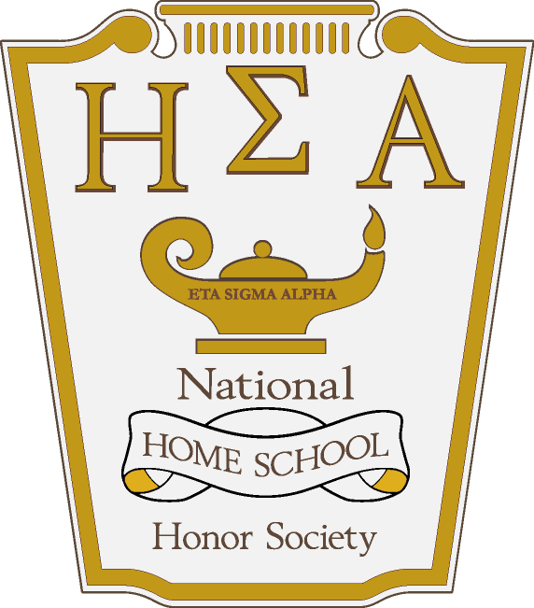
Beta Tau Chapter

Eta Sigma Alpha National Home School Honor Society
Sponsored by the National Organization of ESA

11665 Fuqua, STE A-100 Houston, TX 77034

281-922-0478; 281-922-0504 (fax)

etasigmaalpha.com

Dear Prospective ESA Member,

Attached is an application for membership in the Beta Tau Chapter of Eta Sigma Alpha National Home School Honor Society.

Students must submit the attached application and all required documentation. Dues shall be $20.00 per year. Once approved, students will receive a membership card and a certificate of membership.

To remain active, students must submit 10 hours of service each year. The service record form is attached to this application. Failure to submit the service-hours form will result in a forfeiture of membership.

Graduating seniors are eligible to order an ESA Diploma of Graduation from the HEP Bookstore. Students may also order a gold honor cord and ESA shawl for graduation. Other paraphernalia such as ESA tie tacks, pins, t-shirts, caps, sweatshirts, tote bags, and polo shirts are available for purchase. Visit the www.etasigmaalpha.com webpage for more information about these products.

Once again, thank you for your interest in ESA. We hope you will consider joining. Congratulations on your success as a home school student. We wish you the best in your future endeavors.

Sincerely,
Melissa Price
Melissa Brouillette
pechonorsociety@gmail.com

