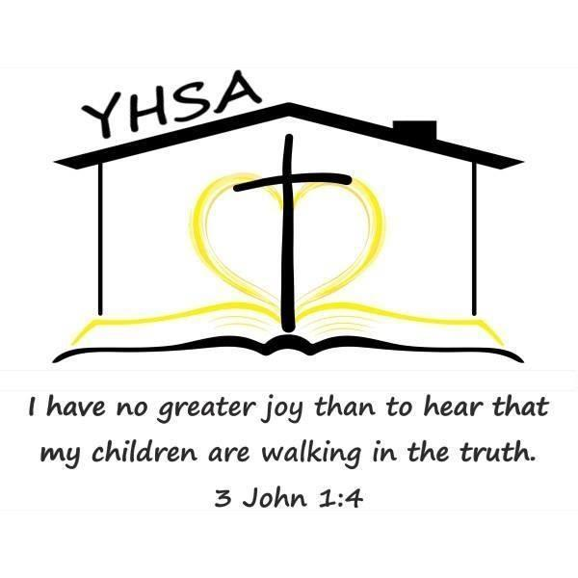
2026-27 Evaluator Questionnaire

Name: ______________________________________________Date: _________________________

Are you a current or alumni member of YHSA? CURRENT ALUMNI NEITHER

- Which of the following are you qualified/approved to do: (Please check all that apply)

    - Elementary Evaluations (beginner through grade 6)
    - Secondary Evaluations (grades 7 through 12)
    - Approval of Objectives for special needs students

- Under which of the following do you evaluate in Pennsylvania? (Please check all that apply.)

- Licensed clinical or school psychologist.

- Teacher certified by the Commonwealth with at least two years of experience at the elementary level (through grade 6) grading any of the following subjects: English, to include spelling, reading, and writing; arithmetic; science; geography; history of the United States and Pennsylvania; and civics.

- Teacher certified by the Commonwealth with at least two years of experience at the secondary level (grades 7-12) grading any of the following subjects: English, to include language, literature, speech, reading and composition; science, to include biology, chemistry and physics; geography; social studies, to include economics, civics, world history, history of the United States and Pennsylvania; foreign language; and mathematics, to include general mathematics, algebra, trigonometry, calculus and geometry.

- Nonpublic school teacher or administrator with at least two years of teaching experience at the elementary level within the last 10 years (grading any of the following subjects: English, to include spelling, reading and writing; arithmetic; science; geography; history of the United States and Pennsylvania; and civics) in a Pennsylvania public or nonpublic school.

- Nonpublic school teacher or administrator with at least two years of teaching experience at the secondary level within the last 10 years (grading any of the following subjects: English, to include language, literature, speech, reading and composition; science, to include biology, chemistry and physics; geography; social studies, to include economics, civics, world history, history of the United States and Pennsylvania; foreign language; and mathematics, to include general mathematics, algebra, trigonometry, calculus and geometry) in a Pennsylvania public or nonpublic school.

- Other qualifications with the prior consent of the district superintendent.

(Answer questions below only if you evaluate under this option):

Please give a brief summary of your qualifications:

Please list the districts which have given consent for you to perform evaluations under “other qualifications”:

- Do you currently or have you ever educated your own children/grandchildren at home?

NO YES, under Home Ed Law YES, under Private Tutor option Yes, through a cyber school

If yes, what ages of children or number of years?

- How long have you been conducting home education program evaluations?

- What is your educational philosophy?

- What types of home education programs do you have experience evaluating? (Circle all that apply)

Traditional School at Home * Relaxed/Eclectic * Unschooling * Classical Conversations * Charlotte Mason

Other: ___________________________________

- Where/how do you conduct evaluations: Circle all that apply.

Your home Client’s home Public places such as parks, etc. Telephone

Video chat/Zoom Email Other : ____________________________________________________

- The PA Home Education Law states an “annual written evaluation of a student’s academic progress…. shall also be based on an interview of the child and a review of the portfolio...and shall certify whether or not an appropriate education is occurring.” Portfolio is defined as “a log, made contemporaneously with the instruction, which designates by title the reading materials used, samples of any writings, worksheets, workbooks or creative materials used or developed by the student and in grades three, five and eight results of nationally-normed standardized achievement tests in reading/language arts and mathematics or the results of Statewide tests administered in these grade levels.” Appropriate education is defined as, “a program consisting of instruction in the required subjects for the time required in this act and in which the student demonstrates sustained progress in the overall program.”

What do you require families to provide in their portfolio or interview to demonstrate progress?

- What is your religious affiliation, if any? ________________________________________

- What is your fee for evaluations? _______________________________________________________________

- If qualified, what is your fee for special needs objectives approval? _________________________________

- Do you have references available upon request? YES NO

- Please indicate your preferred method of contact:

EMAIL: ____________________________________________________________________________________

TELEPHONE: _____________________________________________ TEXT? YES NO

