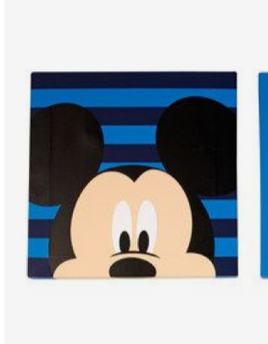 September Painting – Mickey Mouse

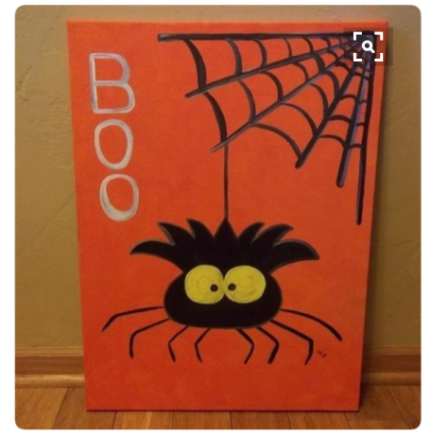 October Painting – Spider with web

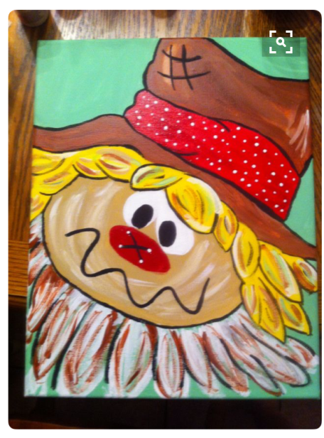 November Painting – Scarecrow

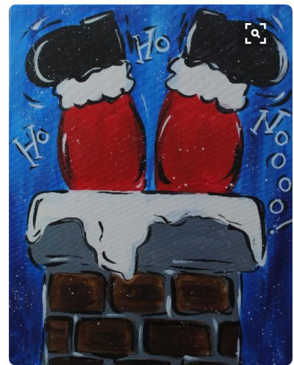December Painting- Santa coming down the chimney

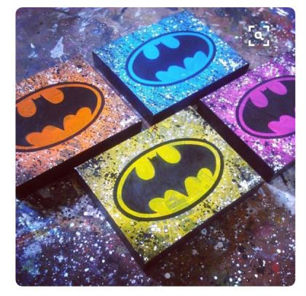January Painting – Batman Symbol (The kids can pick which color they want. So it can be for boys and girls.

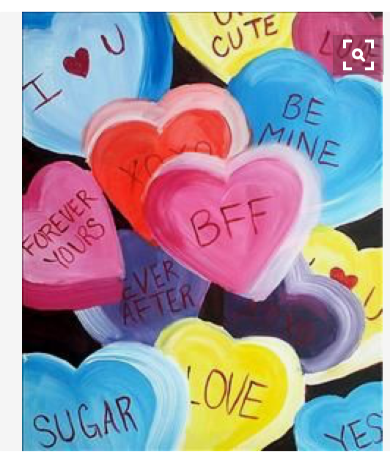 February Painting- Candy Hearts

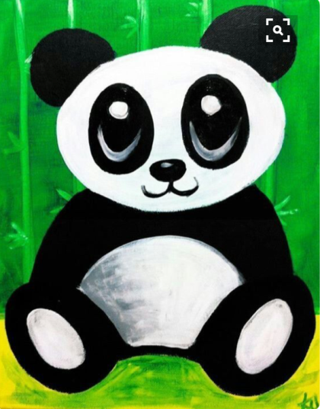 March Painting – Panda

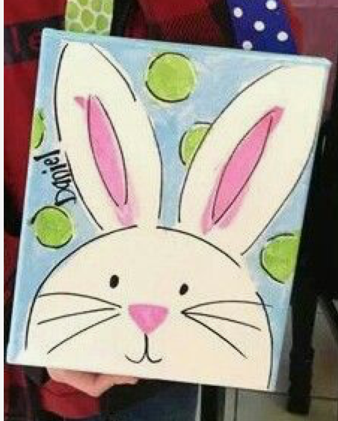 April Painting – Bunny

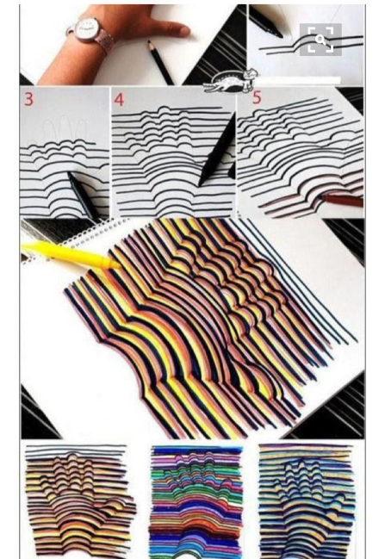 May Painting – Drawing of hand and then add the colors
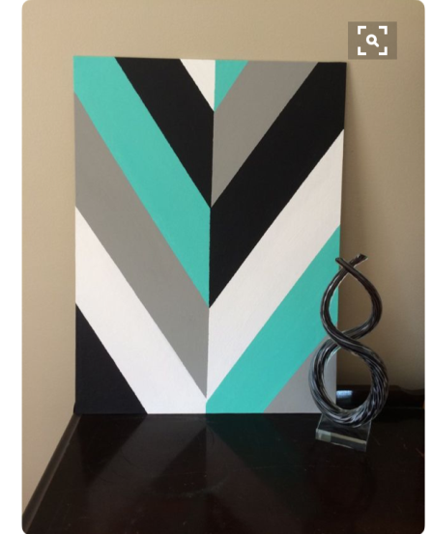 June Painting – Geometric Art

