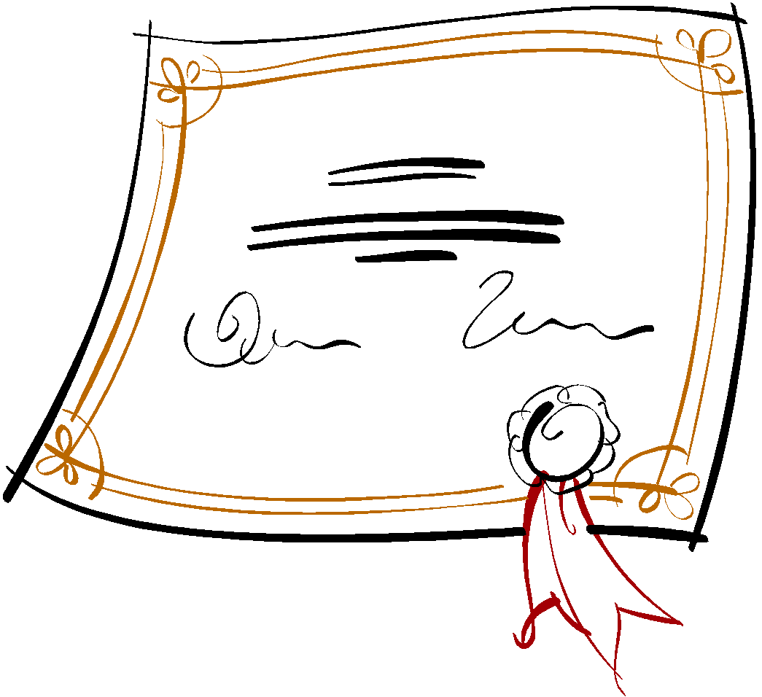
Broward Homeschool Parent Support Group
Promotion Night
Victory Life Church
Thursday, May 9, 2019 7:00 PM

STUDENT’S NAME:
GRADE COMPLETED:
Each student can be individually recognized for any awards, accomplishments or achievements (no more than six) for the 2018-2019 school year.

Examples of the above could be participation in activities such as Standing Ovation Theatre, Saints PE, South Florida HEAT, Awana, Scouts, Sports Teams, Music, Drama, Dance, Art, Learning to Read, Riding a Bike, etc.

1.__
2.__
3.__
4.__
5.__
6.__
PARENTS:
1. Fill out the form including your child’s accomplishments, awards or achievements.
2. Save the document on your computer after you have filled it out 3. Email the completed form to Kia Howell at psg.elementary@gmail.com by May 3rd, 2019 in order for your child to receive a promotion certificate.

