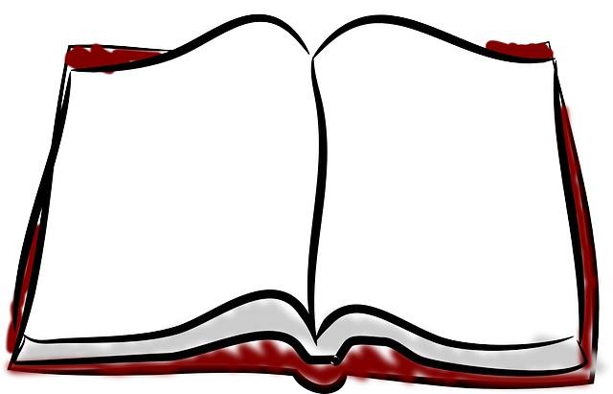
“Meet the Author” & Writing / Art Class

Tuesday Faith Church
December 10 107 E. Vance
10am-12pm Fairmount, 61841

~ An Exclusive Opportunity for Homeschool families; RSVP required
~ Featuring Denice Goldschmidt: Entrepreneur, Professional Artist, & Author/ Illustrator of 3 Self-Published Christian Children’s Books

Author’s Testimony & How to Get Started
All Ages Welcome Story Time Q&A
Book Writing Basics Fun Drawing Lesson
Meet the Real Characters in Denice’s Books
Book Signing by Author Come be Inspired!

This is not a drop-off event. It is free of charge, and all supplies are provided. Please have each student bring a favorite stuffed animal, action figure, doll, toy, or trinket, which they will learn to draw.
For those interested, bring sack lunches for fellowship and play after. Text RSVP to Leanna Bolden: 972-439-0125 by Dec. 6

