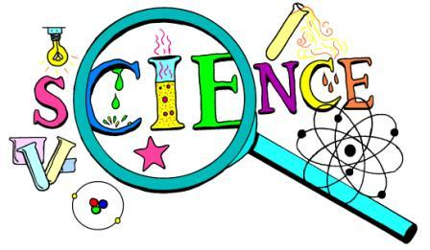

FAIR

**April 8, 2021**

**5:30 – 8:00 PM @ Cedar Street Church in Holt**

**Open to all area homeschoolers**

**Individuals or Teams in Pre-K – 12th**

**Register by April 1st at** [**http://tiny.cc/CHESS_sci_2021**](http://tiny.cc/CHESS_sci_2021)

(<https://www.eventbrite.com/e/chess-2021-homeschool-science-fair-registration-134796406681>)

**Email questions to Amy Finkenbinder: jrapha2000@hotmail.com**

**FREE Family Event**

Science Demos

Prizes!