Fire Safety Field Trip to the PA National Fire Museum

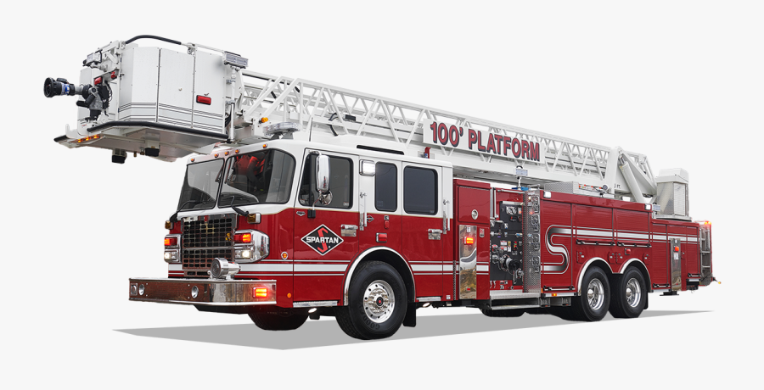

We pulled the alarm on a 1920’s Gamewell Fire Alarm and saw a 1792 hand pumper fire truck! We learned about creating a fire escape plan and how to check our smoke detectors but my favorite part was:

________________________________________________________________________________________________

________________________________________________________________________________________________

This certifies that ___________________________________ attended HAHA’s PA National Fire Museum field trip.

Signed: _________________________________ Date: _____________

