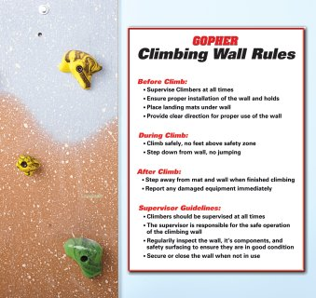  - Climbers must be always supervised  - Climbers must be in athletic attire and not wearing jewelry  - Climbers must keep their feet below the Red-Relief® Line  - Climbers may not climb over, under or around another climber  - Climbers should climb down when ending their climb – no jumping  - Climbers should quickly leave the mats when finished climbing  PART TWO: Safety Surfacing  Safety surfacing is an important component to managing risk and must be in place before climbers get on the wall to offer a cushioned landing surface in the event of a fall. Climbing walls should have a six-foot fall zone, meaning that safety mats should be placed at the base of the climbing wall and extend out six feet. Ideally the safety mats should be two or three inches thick and attach to each other and to the base of the climbing wall to ensure that they always stay in place. |  | Policies/procedures  Rock climbing wall  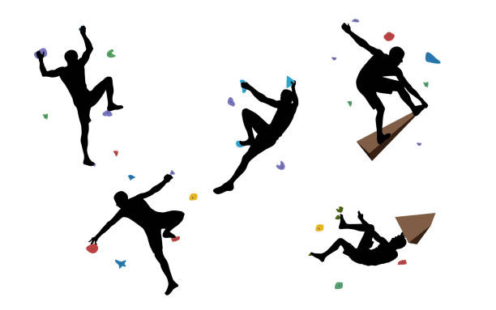  - All Climbers will stand single file along the baseline. Climbers will start on the Left and climb to the Right.  - Only Four climbers aloud on the wall at one time. Climbers must wait for the participant in front of them to clear the first section before beginning their climb.  - After completing the wall participants must report to the back of the line.  NOTE: Any Climber that Falls Off the wall at any time during their climb must report to the back of the Line**************  Observations:

