Polices/Procedures  - We take your child's safety seriously. Patrons not following the safety rules should be asked to leave the bounce house.  - Remove shoes prior to entering the bounce house.  - All bouncers must empty their pockets before entering the bounce house. Falcon Center is not responsible for articles lost during operation of the bounce house.  - All bouncers must remove eyeglasses, jewelry, and any hard or sharp objects before entering the bounce house.  - Absolutely NO flips, wrestling, or other forms of rough housing are allowed in the bounce house.  - Do not run and/or bounce against the walls of the bounce house.  - Do not bounce any closer than two feet from each other or two feet from the door.  - Do not run or jump through the door of the bounce house.  - Our bounce house is equipped with a safety entrance. Bouncers must enter and exit the bounce house from a sitting position.  - Do not climb or hang from the interior or exterior of the bounce house. |  | Bouncy House SAFETY RULES & OPERATING INSTRUCTIONS  Bouncy House  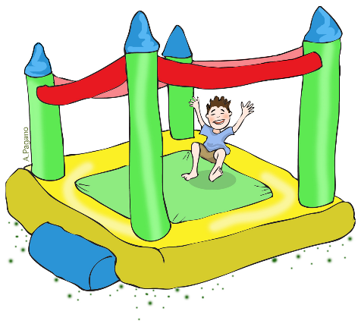  *Safety is our number one (1) priority. Patrons not following the safety rules should be asked to leave the bounce house.  Maximum Occupancy (4)  Observations:

