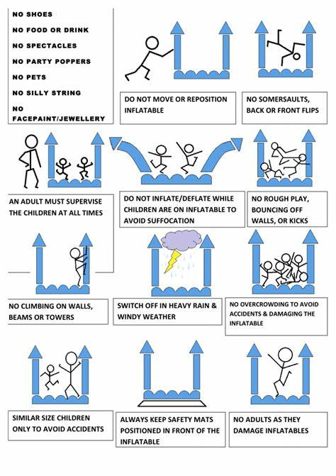 |  | Obstacle course  Policy/Procedures
1)All Participants must take Shoes off and line them up neatly along the baseline.  2)All Participants must stand in line Single File in front of the two yellow tunnels on the safety mats provided.  3) After completing the obstacle Course Participants must return to the back of the line.  4) Participants must wait until the group ahead of them returns to the line before entering the obstacle. |  | obstacle SAFETY RULES & OPERATING INSTRUCTIONS  Do not allow children to enter the inflatable without ADULT supervision. Do NOT allow older children to jump with younger children - risk of severe injury  Only children of compatible age and size should be in the inflatable at the same time. Mixing children of different sizes will greatly increase the risk of injury. Depicted below are the maximum number of participants for each group that may play at the same time:  -Two Participants @ A Time- One(1) in each Lane.  -No Headfirst Diving Down the Slide.  Observations

