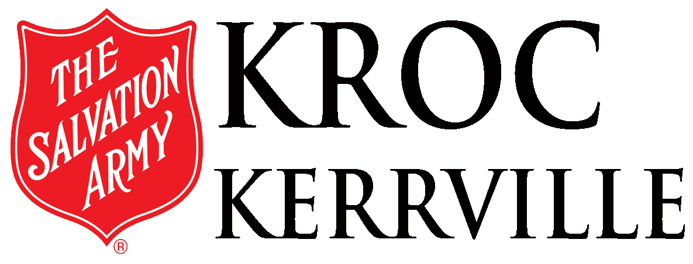

Day, HydroMassage & Climbing Wall Use Agreement

PRIMARY ADULT/GUARDIAN (Adults must have valid picture ID)
NAME (FIRST, MI, LAST) BIRTHDATE
Filled out by Kroc Center staff:
PRIMARY ADULT ID:
□ State ID □ Driver’s License
□ Passport □ Other________

ID#_________________________

SECONDARYADULT ID:
□ State ID □ Driver’s License
□ Passport □ Other________
ID#_________________________
STAFF VERIFICATION:
Initials: Date:
□ MALE □ FEMALE PHONE
EMAIL
ADDRESS _____________________CITY STATE ZIP

Check One: Facility Use_____ Massage Use_____ Facility & Massage Use_______ Climbing Wall_____

ADDITIONAL HOUSEHOLD MEMBERS)
NAME (FIRST, MI, LAST) BIRTHDATE □ MALE □ FEMALE
NAME (FIRST, MI, LAST) BIRTHDATE □ MALE □ FEMALE
NAME (FIRST, MI, LAST) BIRTHDATE □ MALE □ FEMALE
NAME (FIRST, MI, LAST) BIRTHDATE □ MALE □ FEMALE
EMERGENCY CONTACT INFORMATION- Required and must be filled out by applicant.
NAME (FIRST, MI, LAST)
RELATIONSHIP TO APPLICANT
CELL PHONE ALTERNATE PHONE
*

LIABILITY WAIVER – I understand that the use of facilities and equipment at The Salvation Army Kroc Center may involve risk of bodily injury or property damage. I agree to assume such risks to me and on behalf of all minors on the Membership Application, Day Pass, or other form of admittance to the Kroc Center. I understand it is up to me to consult with physicians or other medical professionals to ensure that I and my minors can safely participate in activities and events at The Salvation Army Kroc Center. I understand and agree that I am relinquishing my right and the rights of my estate or heirs to make any claim of any nature against The Salvation Army, its agents, employees, and volunteers.
Member Initials____________
I represent to The Salvation Army, that neither I, nor anyone I am signing on the behalf of, are registered sex offenders in any legal jurisdiction and that furthermore, I have an affirmative duty to The Salvation Army to immediately disclose to The Salvation Army any change in registered sex offender status for myself or anyone I am signing for who seeks admittance at the RJKCCC. For the safety of all concerned, membership is denied to known registered sex offenders.
Member Initials____________
NOTICE - In order to promote a safe and secure environment, The Salvation Army Kroc Center has placed video cameras in various locations. As part of our commitment to the safety of children and vulnerable persons, The Salvation Army Kroc Center reserves the right to consult public sources to determine whether any member or guest of any member poses an unreasonable risk of harm to its patrons, staff, or visitors.
RELEASE AUTHORIZATION – I hereby agree to each of the consents and waivers listed above, including the Liability Waiver, as pertaining to my own or my minor’s participation, in functions, activities, special events, and field trips. I hereby certify that I am the parent/legal guardian of all minor children or dependents on the Membership Application, Day Pass, or other form of admittance to the Kroc Center and have executed these releases on (his)/(her) behalf.
Member Initials____________
I understand that this is a legal document. I acknowledge that I have read this document and that I understand the words and language in it
MEMBER/Guardian SIGNATURE_________________________________________ DATE_________________
PRINTED MEMBER NAME____________________________________________
Staff Initials__________
Revised 3/12/2021

