Kool Skool

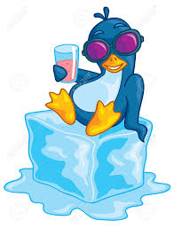

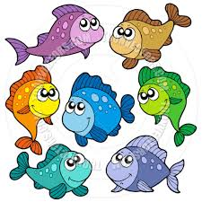

Creative Writing 1, 2: Students will be engaged in writing a wide variety of different selections including poems, letters, essays, stories, etc. Writing tips, rules and procedures will be taught. Groups or individuals. Grades 3-5

Author Studies 1, 2: Students will discover entertaining qualities of various authors of children’s books while evaluating, analyzing, and comparing/contrasting characteristics of literature. Groups and individuals. Grades K/1 and 2/3.

Texas 1, 2: Part 1 Students will explore the geography, culture, & historical events of Texas; Part 2 Students will continue study of historical events & identify unique wildlife, landmarks, and attractions in Texas. Groups or individuals. Grades 3-5

Elizabeth Dykes eduk8r56@hotmail.com

Certified General Elementary Ed 1-8

Certified Creative Drama 1-8

Certified Learning Resources/Librarian PK-12

30+ years of experience, a published author

Courses offered Sept.-Dec., 2020 and Jan.- May, 2021 Parts 1 and 2

Puppets Parts 1 & 2: Students will make a different puppet each week and will write and perform puppet shows using the puppets they create. Parents will receive a list of supplies in advance. Groups or individuals. Grades 3-5

