SHC Invoice Payment Instructions

When an invoice has been assigned to your account on the SHC website, you will receive an email. The email will contain 2 links: Pay now & View statement of Account (they are highlighted in orange).
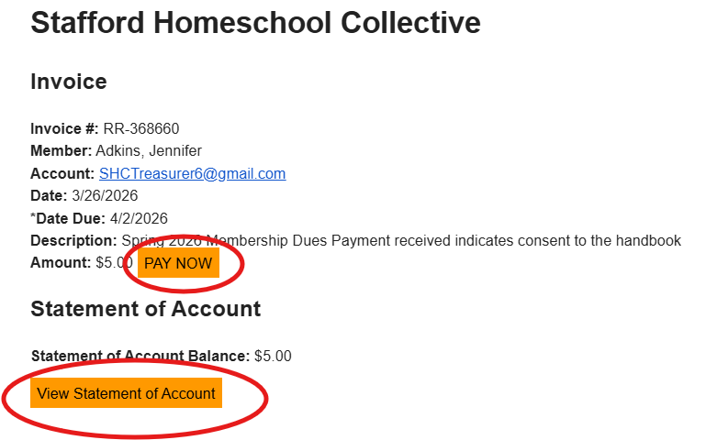

Both links will take you to the SHC homepage where you can log in. It will automatically take you to your accounting page where you can see the invoices that are due.
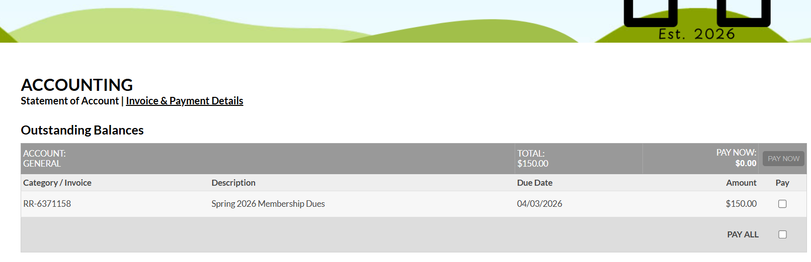
Check the invoices you would like to pay.
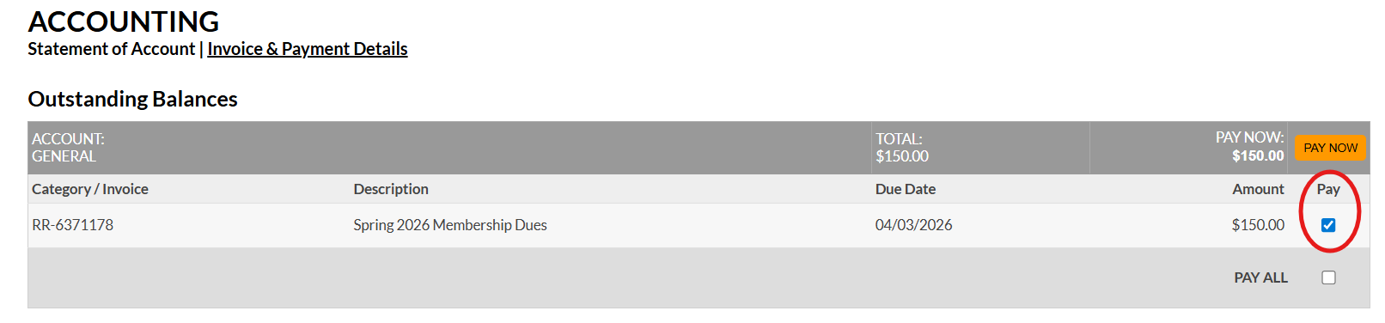

You can then click on the Pay Now button if you want to pay by PayPal, debit, or credit card. This link will take you to PayPal to complete the checkout process. You may also pay by Zelle, check, or cash. If you need to set up a payment plan, please contact our Treasurer, Jenn Adkins. She will be happy to work with you to set up what works best for your family.

- For PayPal, debit, or credit card payments: Use the link on the SHC website invoice page to login to PayPal. Complete the checkout process
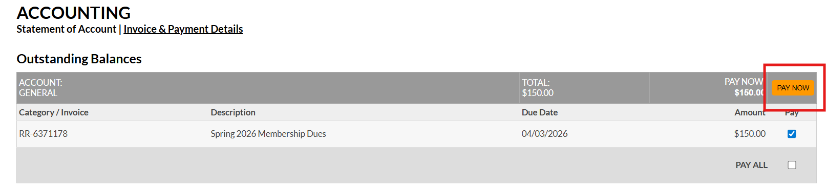

- For Zelle payments: The name of the company/recipient is Stafford Homeschool Collective. The email is SHCTreasurer6@gmail.com. Please do NOT use a phone number for Zelle. Our bank account is connected with the email. 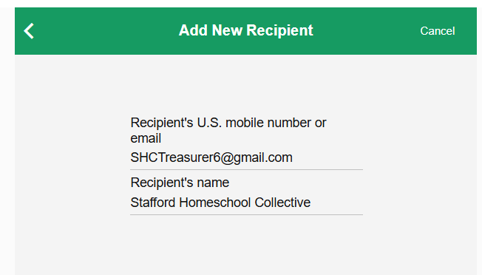

- For check payments: Please make the check out to Stafford Homeschool Collective and give it to our Treasurer, Jenn Adkins.
- For cash payments: Please give the money to our Treasurer, Jenn Adkins.

Once payment has been received, your invoice will be marked as paid. You will be able to see this reflected under the Accounting – Invoice & Payment details tab. If you pay through PayPal, the invoice will automatically reflect the paid status once the checkout is complete. If you pay by Zelle, check, or cash, it may take up to 48 hours to see the invoice marked as paid. You will also receive an emailed receipt.
